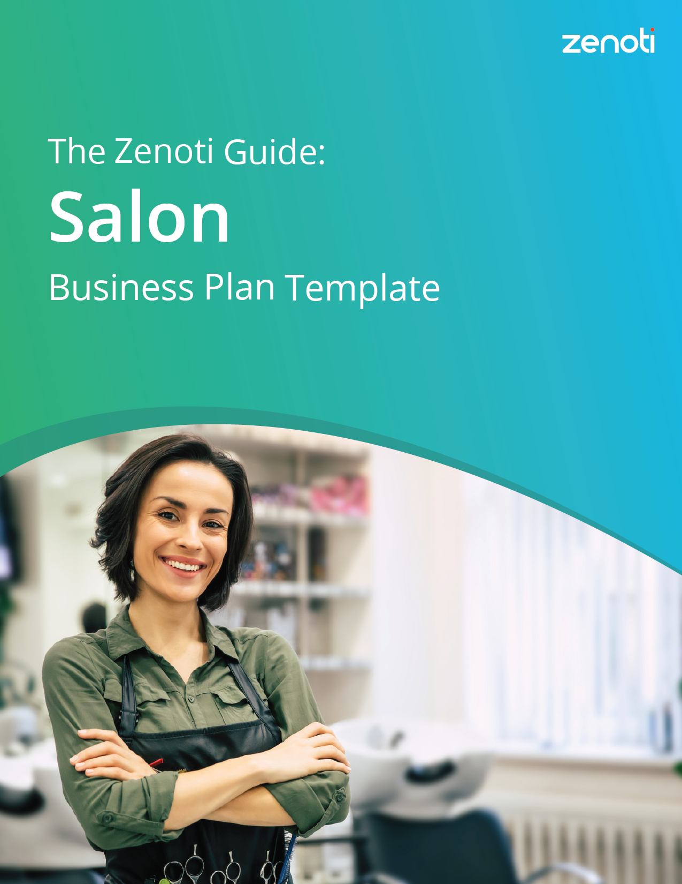

What is a business plan
—and why is it important?
Business plans outline the goals and objectives of a business, as well as the strategies and action plans for achieving those goals. Writing a business plan is invaluable for any business, whether it’s a small startup or a large corporation, and whether it’s only for internal purposes
or for interested investors.

A business plan does the following:
- Helps you define the goals and objectives of your business, as well as the strategies and action plans for achieving those goals. This gives your business a sense of direction and purpose.
- Supports you in finding potential obstacles and challenges and gives you the framework to develop strategies to overcome them.
- Gives you the resources to attract investors and secure funding.
- Keeps you organized and focused by using a business plan as a guide.
- Helps you monitor your progress and make necessary adjustments to your strategies and action plans.

How to use this template
Below is a customizable template for developing your salon business plan. Skim through it to understand what is typically included in a business plan. Then, determine which sections of the template are best for your business and its growth plans, and fill in the blanks. It’s recommended you make a copy of this document, so you can have one for reference, and use the other as your company’s business plan.
Share your completed plan with potential investors, company leadership, or anyone else who needs to see it. This template is designed to fit your company, so feel free to add or omit sections as needed.

Each section of the business plan template includes:
- A definition of the section.
- Ideas for what to include when writing each section.
- An example to use as inspiration.

Scroll down for your template!

Logo

[Salon Name]

[Your Salon Address]

[Your Salon Phone Number]

Prepared By:
[Your Name], [Your Role]
[Your Email]

Table
of Contents
Executive summary | ##
Company overview | ##
Product or services offered | ##
Market analysis | ##
Marketing plan | ##
Logistics and operations plan | ##
Financial plan | ##
Infographic | ##

Executive summary

What is an executive summary?
An executive summary offers a high-level overview of your business plan and should grab the reader’s attention. It is concise and provides the reader with the key points of the plan.

HINT
Fill out this section of your business plan last.
It’s easier to work through the rest of your plan using this template,
then come back to the executive summary.

Here’s what to include in your executive summary:
- Mission statement. What are the goals and values of the business?
- Business concept. What does your business do?
- Business goals and vision. What does your business want to do?
- Product description and differentiation. What do you offer and why is it unique?
- Target market. Who are your customers?
- Competitive advantage. What sets you apart from competitors?
- Financial projections. What is your expected revenue and profit?
- An ask from potential investors. How much funding are you seeking?

Executive summary example
[Your Salon Name] is a premier hair and beauty destination offering top-notch services in a stylish and welcoming environment. Our mission is to enhance our clients' natural beauty and boost their confidence through expert hair care, styling, and beauty treatments.
We provide a range of services including haircuts, coloring, styling, nail care, and makeup application. Our treatments are administered by skilled stylists and beauty professionals in a modern, inviting atmosphere.
The salon aims to be the leading choice for individuals seeking high-quality hair and beauty services, focusing on exceptional results and an unparalleled client experience. We target fashion-conscious individuals who prioritize personal grooming and desire effective, professional beauty treatments.
To reach our audience, we leverage a strong online presence, social media engagement, and local partnerships. Our marketing emphasizes our unique blend of expert stylists, trendsetting techniques, and a luxurious salon experience.
We seek investors to support service expansion and new location openings. In the next year, we project revenue of $500,000 and a net profit of $100,000. Our growth strategy includes investing in the latest beauty technologies, increasing marketing efforts, and expanding our expert team.
With our innovative approach, experienced stylists, and commitment to client satisfaction, we are poised for significant growth and success in the competitive salon industry.

Company overview

What is a company overview?
This section of your business plan will answer two fundamental questions: “Who are you?” and “What do you plan to do?” It details the reasons for your business’s existence, its goals, and its guiding principles.

Components you should include in your company overview:
- An explanation of your company’s purpose and mission
- An overview of your business objectives
- A description of your products or services
- A summary of your competitive advantage
- An overview of your team and organizational structure

Here’s what to include in your company overview:

An explanation of your company’s purpose and mission
- Identify your core values and the people your company is accountable to, including owners, employees, suppliers, customers, investors, and the community where you do business. Use these values to craft a concise mission statement that explains why your business exists and what it aims to accomplish.
- Create a clear and concise mission statement that outlines the impact you want your business to have on the world.

An overview of your business objectives
- Include both short- and long-term goals in the company overview section of your plan. In the context of a business, short-term goals are ones you plan to achieve in the next year, while long-term goals are ones, you’re aiming for in the next one to five years.

A description of your products or services
- Include information about your products or services, and outline their features, benefits, and any unique selling points.
- Highlight key features and benefits of your products or services and explain how they solve a problem or meet a need for your customers.

A summary of your competitive advantage
- Identify what sets your business apart from your competitors and the value it provides to your target customers. This could include unique features or benefits of your products or services, a distinctive brand or reputation, a loyal customer base, or any other advantage that gives you an edge in the market.
- Summarize your competitive advantage in a few sentences or bullet points. Focus on the benefits your advantage brings to your customers, and how it sets you apart in the market.

An overview of your team and organizational structure
- Insert an org chart of your existing team, and any predicted hires, with their salaries.
- Include details about the founders, executives, and other team members, as well as information about their roles and responsibilities.
- If you’re a solopreneur, include an overview of your professional background and any experience or qualifications that relate to your developing business.

Company overview example
[Your Salon Name] is a premier destination offering high-quality hair and beauty services. Our mission is to enhance natural beauty and boost confidence through expert hair care, styling, and beauty treatments in a stylish and welcoming environment.
We provide a range of services, including haircuts, coloring, styling, nail care, and makeup application. Our focus is on delivering exceptional results using the latest techniques and high-quality products.
Our competitive advantage is our team of expert stylists, our use of premium products, and our commitment to staying at the forefront of hair and beauty trends. Our team consists of experienced hair stylists, colorists, and beauty professionals with a combined 20 years in the industry, ensuring the highest standards of service and results.
Our strong brand recognition and loyal customer base are supported by our commitment to client satisfaction and continuous improvement. Our flat organizational structure promotes open communication and agility, allowing us to quickly adapt to client needs and industry trends.
[Your Salon Name] is dedicated to promoting beauty, confidence, and self-expression, positioning us as a leader in the salon industry. Our focus on innovation and personalized care ensures continued growth and success.
.

Product or services offered

Explain what product and services your business offers:
This section is for potential investors. Detail your products or services and why they are valuable to your target customer. Demonstrate why your business is worth investing in.

Here’s what to include in your product or services offered section:

Features and benefits of your offering
- Include information about each service and products your salon offers.

Information about your pricing model
- How you price your services and any packages available.

Product or services offered example
[Your Salon Name] provides a range of hair and beauty services to enhance our clients' natural beauty:
- Hair Services:
- Haircuts and styling for all genders
- Hair coloring (full color, highlights, balayage)
- Hair treatments (deep conditioning, keratin treatments)
- Beauty Services:
- Manicures and pedicures
- Makeup application
- Waxing and threading
- Lash and brow services
- Retail Products:
- Professional-grade hair care products
- Makeup and skincare items
Pricing Details:
- Women's Haircut: $50-$100
- Men's Haircut: $30-$60
- Hair Coloring: $80-$200+
- Manicure: $25-$40
- Makeup Application: $50-$100

Our salon offers personalized care with a focus on high-quality services and expert professionals, ensuring clients achieve their beauty goals.

Market analysis

What is a market analysis?
A market analysis is a study of the current market conditions for a particular product or service. This includes understanding market size, competition, and trends to identify opportunities and challenges.
To analyze your business, choose two to three examples from this list of market analysis techniques:

Target market
- Specific group of consumers your business is trying to reach with its products or services.

Competition and market share
- Understand your competitors, including their products, prices, and marketing strategies, and determine your market share and how it compares to your competitors.

Market size and growth
- The overall size and growth of the market for your products or services compared to similar markets or industries.

Customer demographics and behavior
- The characteristics of your potential customers, like their age, income, location, and preferences when it comes to your products or services. You can also develop buyer personas or lookalike customers that represent your business’s target market.

Market trends and opportunities
- The current and future trends in the market, including technological, economic, and social trends. Use this research to identify opportunities for your business and to differentiate it from competitors.

Market challenges and threats
- Changing customer preferences, new competitors, or regulatory changes, and creating strategies to mitigate or overcome these challenges.

SWOT analysis
- A type of planning tool that can help you identify your business’s strengths, weaknesses, opportunities, and threats (hence SWOT). It helps businesses to understand their current situation, and to develop strategies to achieve their goals and objectives. It can also provide a framework for decision-making and continuous improvement. (More below.)

Market analysis example

Target market
[Your Salon Name]'s target market consists of fashion-conscious individuals seeking high-quality hair and beauty services. These are primarily young to middle-aged professionals and beauty enthusiasts who value expert care and personalized attention.
Our target market is:
- Interested in maintaining an attractive and well-groomed appearance
- Willing to invest in premium hair and beauty treatments
- Looking for a luxurious and relaxing salon experience
- Socially active and image-conscious, often sharing their experiences on social media
- Predominantly female, but with a growing number of male clients

Market size and growth
The salon industry is stable and growing, driven by increasing demand for professional hair and beauty services. The global hair care services market is expected to reach $112.5 billion by 2025, with a compound annual growth rate (CAGR) of 4.6%.

Competition
Competition in the salon market comes from three primary sources:
- Large, established Salon chains:
These chains have significant market share, offering a wide range of services. They have strong brand recognition and extensive marketing campaigns.
- Independent local salons:
These are often owner-operated businesses with loyal local clientele.
- High-end luxury salons:
These salons cater to a more affluent clientele, offering premium services and exclusive products.
[Your Salon Name] differentiates itself through its blend of expert stylists, trendsetting techniques, and a luxurious yet welcoming atmosphere, all at competitive pricing.

SWOT analysis

Strengths
- Skilled and experienced stylists
- Use of high-quality, professional products
- Strong focus on customer satisfaction
- Trendy, welcoming salon environment
- Diverse range of services

Weaknesses
- Limited brand recognition compared to larger chains
- Smaller marketing budget
- Limited number of locations
- Dependence on key staff members

Opportunities
- Growing demand for professional hair and beauty services
- Increasing male grooming market
- Potential for product line expansion
- Opportunities to open new locations

Threats
- Intense competition from established chains and independent salons
- Economic downturns impacting discretionary spending
- Rapid changes in beauty trends
- Difficulty in retaining skilled staff

Want to conduct a SWOT analysis on your business?
Use this graph as a guide.
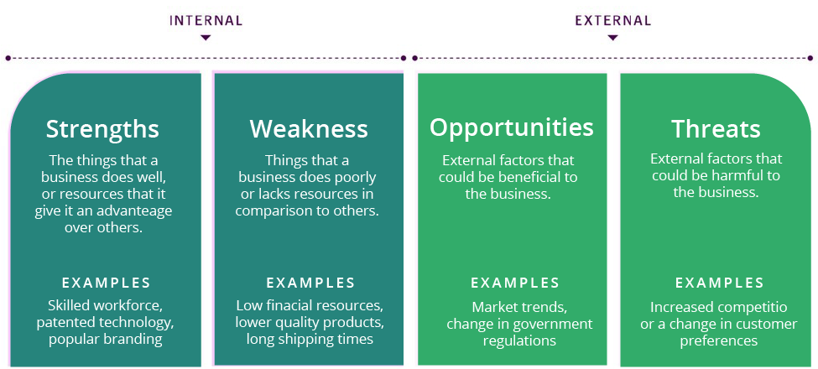

Marketing plan

What is a marketing plan?
A marketing plan details marketing strategies and tactics your business will use to achieve its sales goals.

Developing a marketing plan will help you do the following:
- Understand your business’s target market and the needs and preferences of your customers.
- Identify unique selling points of your products or services and develop marketing messages to highlight those points.
- Develop a clear and effective marketing strategy that aligns with your business’s goals and objectives.
- Set specific, measurable, achievable, relevant, and time-bound goals and objectives (SMART).
- Allocate resources, such as budget and personnel, to impactful marketing activities.
- Track and measure the effectiveness of your marketing plan and make needed adjustments.

Here’s what to include in your marketing plan:

Positioning strategy – How you differentiate your services.

Acquisition channels – Methods to reach and convert customers.

Tools and technology – Software and tools for marketing efforts.

Goals and evaluation
- Revenue and sales
Use metrics like total revenue, average order value, or conversion rate.
- Traffic and engagement
Look into website traffic, page views, or social media followers.
- Brand awareness and perception
Understand brand recognition rate, net promoter score (NPS), or customer satisfaction.
- Customer acquisition and retention
Customer lifetime value (CLV), churn rate, or customer satisfaction focus on retention.

DEFINITION
Customer lifetime value (CLV)
Customer lifetime value (CLV) is a prediction of how much money a customer will spend on a company’s products or services over their lifetime. It helps businesses understand which customers are the most valuable and how to allocate resources for customer acquisition and retention.

Marketing plan example

Positioning statement
[Your Salon Name] provides high-quality hair and beauty services in a stylish, welcoming environment. We combine expert techniques with personalized care to enhance our clients' natural beauty and boost their confidence. Our commitment to staying ahead of beauty trends and providing exceptional customer service sets us apart in the salon industry.

How [Your Salon Name] acquires customers:
- Social media marketing
We use Instagram, Facebook, and Pinterest to showcase our work, share beauty tips, and engage with potential clients. We regularly post before-and-after photos, styling tutorials, and behind-the-scenes content.
- Local SEO and Google My Business
We optimize our online presence for local searches and maintain an up-to-date Google My Business profile with current photos, services, and customer reviews.
- Referral program
We incentivize our existing clients to refer friends and family with discounts on future services.
- Partnerships
We collaborate with local businesses, fashion boutiques, and wedding planners to cross-promote our services.
- Email marketing
We send regular newsletters featuring beauty tips, new services, and special promotions to our subscriber list.
- In-salon promotions
We offer seasonal specials, package deals, and loyalty programs to encourage repeat visits and try new services.

Our tech stack
- Zenoti: We manage our appointments, client records, inventory, point-of-sale transactions and promotions through Zenoti. This platform helps us:
  - Schedule and manage appointments efficiently.
  - Communicate with clients through email and SMS reminders.
  - Track client preferences and history to personalize services.
- Google Analytics: We measure the impact of our digital marketing efforts and identify website traffic patterns. This tool helps us understand our audience's behavior and optimize our online content.
- Social Media Management Tools: We use tools like Hootsuite or Buffer to schedule and manage our social media posts across platforms.
- Email Marketing Platform: We use [Platform Name] for creating and sending targeted email campaigns to our subscriber list.

Logistics & operations plan

What is a logistics and operations plan?
This section outlines the day-to-day operations of your salon, including the facilities, equipment, and human resources needed.

Here’s what to include in your logistics and operations plan:

Facility management – Location, layout, and design.

Staffing requirements – Roles, responsibilities, and hiring plans.

Equipment and supplies – Necessary salon equipment.

Operational workflow – Patient intake, service delivery, and follow-up processes.

This section should show you’ve got a solid understanding of your supply chain, and contingency plans in place to cover potential uncertainty.

Logistics and operations plan example

Suppliers
[Your Salon Name] sources its hair care products, styling tools, and beauty supplies from reputable suppliers and manufacturers. We have established long-term partnerships with these suppliers to ensure the highest quality products and materials. Our suppliers are certified and follow strict guidelines to provide safe and effective products for our clients.

Production and manufacturing
While we don't manufacture our own products, we carefully select professional-grade hair care and beauty products from leading brands in the industry. These products are produced at certified facilities that adhere to stringent quality and safety standards. We prioritize brands that use advanced formulations and environmentally friendly production methods to ensure the products are safe, effective, and sustainable. We also focus on minimal and recyclable packaging to reduce waste and environmental impact.

Distribution and fulfillment
Our salon utilizes a combination of direct sales at our location and online sales through our website to distribute our retail products. We partner with reliable carriers such as UPS, FedEx, and USPS to deliver products ordered online. For salon services, we offer scheduling through our website and in-person at our salon. Our staff manages and coordinates online product orders, providing tracking information and customer support to ensure timely and accurate deliveries.

Inventory management

We use a cloud-based inventory management system integrated with our salon management software to track and manage our stock levels. This system allows us to monitor inventory in real-time, ensuring we have sufficient products to meet client demand for both salon use and retail sales. The system generates reports and alerts to help us make informed decisions about reordering and inventory levels. We operate on a just-in-time inventory approach to minimize waste and ensure that our products are always fresh and ready for use.

Operations
- Client Scheduling and Management: Our scheduling software, Zenoti, helps manage client appointments, track client preferences, and ensure seamless operations. Clients can book appointments online, via phone, or in-person, and receive automated reminders.
- Service Preparation: All styling stations and treatment rooms are equipped with the necessary supplies and equipment, prepared according to scheduled services. Our staff ensures that each area is sanitized and ready for the next client.
- Staff Training and Development: Our team undergoes regular training to stay updated on the latest hair and beauty techniques and trends. This ensures that our clients receive the best possible care and results.
- Client Communication: We maintain regular communication with our clients through email newsletters, SMS reminders, and social media updates. This keeps clients informed about new services, promotions, and beauty tips.
- Quality Control: We have strict protocols in place to ensure the highest standards of hygiene and safety. Regular audits and feedback loops help us maintain quality and continuously improve our services.
- Retail Sales: Our stylists are trained to recommend appropriate hair care and beauty products to clients, enhancing their at-home care routine and providing an additional revenue stream for the salon.

Financial plan

What is a financial plan?
The financial plan includes projections for revenue, expenses, and profitability.

Here’s what to include in your financial plan:

Revenue projections - Expected income from services.
- Expenses projections – Costs related to operations, staffing, and supplies.

Profit and loss statement - Expected profit margins.
- Funding requirements – How much capital is needed and how it will be used.

Financial plan example
Revenue Projections
[Your Salon Name] anticipates steady revenue growth from services and product sales:
Category | Details
Revenue projections | - Year 1: $1.5 million  - Year 2: $2.1 million  - Year 3: $2.8 million
Cost structure | - Fixed Costs:  - Rent: $120,000/year  - Salaries: $600,000/year  - Insurance: $30,000/year  - Utilities: $24,000/year  - Variable Costs:  - Supplies: $200,000/year  - Marketing: $150,000/year  - Inventory: $100,000/year
Profit margins | - Gross Margin: 70%  - Net Profit Margin: 20%
Financial projections | - Year 1: Net Profit: $300,000  - Year 2: Net Profit: $420,000  - Year 3: Net Profit: $560,000
Exit strategy | - Expansion into a multi-location salon chain  - Franchising opportunities  - Acquisition by a larger beauty company

